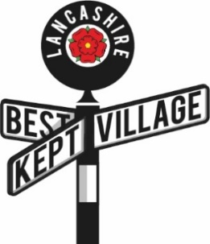**Lancashire Best Kept Village Competition**

**Pen-Picture 2025**

As the Judges for the Best Kept Village Competition come  
unannounced, the Pen Picture is a way you can communicate  
to them things you want them to know about your village.

Communities  
Working

Together

Some ideas are below but please tell the judges  
any additional information you want them to have.

*1 x A4 page maximum please*

**What special things do you want the judges to note?**

⌦

**Are the efforts to make the village look good orchestrated by a group of people, an organization, one person?**

⌦

**Do you leave individual houses to do things themselves or do you have sessions for   
litter-picking, painting benches, planting etc.?**

⌦

**Is there anything you want to explain to the judges (a work in progress, a problem area)?**

⌦

*Send to Competition Organiser*www.lancashirebestkeptvillage.co.uk